

**Project Report**

| **Only for Course Teacher** | | | | | | |
| --- | --- | --- | --- | --- | --- | --- |
|  | | **Needs Improvement** | **Developing** | **Sufficient** | **Above Average** | **Total Marks** |
| **Allocate Marks & Percentage** | | **25%** | **50%** | **75%** | **100%** | **25** |
| **Problem understanding & Analysis** | **7** |  |  |  |  |  |
| **Implementation** | **8** |  |  |  |  |  |
| **Report Writing** | **10** |  |  |  |  |  |
| **Total obtained marks** | | | | | |  |
| **Comments** |  | | | | | |
|
|

Semester: **Fall 2023**

Student Name: MD. Mubtasim Fuad Khan

Student ID: 221-35-883

Batch: **37th** Section: **D2**

Course Code: **SE231** Course Name: **Software Analysis and Design Project**

Course Teacher Name: **Khalid Been Md. Badruzzaman Biplob**

Designation: **Lecturer  
 Department of Software Engineering (SWE)  
 Faculty of Science and Information technology (FSIT)  
 Daffodil International University**

Submission Date: **01 June, 2024**



**Introduction 4**

Objective 4

Key Features 4

**Scenario Writing 5**

Scenario-1: User Registration 5

Scenario-2: Product Search and Filter 5

Scenario-3: Adding Products to Cart 5

Scenario-4: Purchase Process 5

Scenario-5: Order Tracking 6

Scenario-6: Product Review and Rating 6

**Stakeholder 6**

**User Profile 7**

User Profile-01: Customers 7

User Profile-02: Shop Manager 7

**Scope 8**

1. User Registration and Login: 8

2. Add Profile and Update Profile: 8

3. Product Browsing and Selection: 8

4. Shopping Cart Management: 8

5. Order Placement and Tracking: 8

6. Payment Integration: 8

7. Product Reviews and Ratings: 9

8. Notifications: 9

9. Delivery Tracking: 9

**Feasibility Study 9**

1. Technical Feasibility: 9

2. Operational Feasibility: 9

3. Economic Feasibility: 9

4. Scheduling Feasibility: 9

5. Security and Privacy Considerations: 10

**Software Requirement Specification 11**

SRS 11

**Use Case Diagram** 13

**User Case Description** 14

**Case Description-01: User Registration 14**

**Case Description-02: Product Management 15**

**Case Description-03: Browsing Products 16**

**Case Description-04: Shopping Cart 17**

**Case Description-05: Search and Filter 18**

**Case Description-06: Order Placement 19**

**Case Description-07: Payment Integration 20**

**Case Description-08: Product Reviews and Ratings 21**

**Case Description-09: Notifications 22**

**Case Description-10: Order Cancellation 23**

**Case Description-11: Delivery Tracking 24**

**Project Block Diagram** 25

Block Diagram-1: Customer 25

Block Diagram-2: Manager 26

**Activity Diagram** 27

Activity Diagram-1: User Registration and Login 27

Activity Diagram-2: Browsing and View Product 28

Activity Diagram-3: Shopping Cart 29

Activity Diagram-4: Product Management 30

Activity Diagram-5: Search 31

Activity Diagram-6: Order 32

Activity Diagram-7: Payment 33

Activity Diagram-8: Product Reviews and Ratings 34

Activity Diagram-9: Order Cancellation 34

Activity Diagram-10: Delivery Tracking 35

**Sequence Diagram 36**

Sequence Diagram-1: User Registration and Login 36

Sequence Diagram-2: View Product 37

Sequence Diagram-3: Shopping Cart 38

Sequence Diagram-4: Product Management 39

Sequence Diagram-5: Search Product 39

Sequence Diagram-6: Order 40

Sequence Diagram-7: Payment 40

Sequence Diagram-8: Product Reviews and Ratings 41

Sequence Diagram-9: Order Cancellation 41

Sequence Diagram-10: Delivery Tracking 42

**Online Super Shop Project Class Diagram** 43

**Online Super Shop Project ER Diagram 44**

# 

# **Introduction**

The Online Super Shop Management System represents a transformative approach to the retail shopping experience, transitioning from the traditional brick-and-mortar stores to a comprehensive digital platform. This system is designed to bridge the gap between consumers and the products they need, bringing the convenience of shopping to the fingertips of users across a wide demographic. By leveraging modern web technologies, the system aims to provide an efficient, secure, and user-friendly shopping environment that caters to the needs of a diverse user base, including customers, administrators, shop managers, and delivery personnel.

## Objective

The primary objective of the Online Super Shop Management System is to enhance the shopping experience by providing a platform that is accessible, reliable, and capable of meeting the evolving demands of both consumers and businesses. The objectives include:

1. Seamless Online Shopping Experience: To offer both registered and non-registered users a smooth and intuitive shopping experience, allowing them to browse, select, and purchase products with ease.
2. Efficient Product and Inventory Management: To enable shop managers to effectively manage product listings, inventory levels, and order processing, ensuring that the platform remains up-to-date and responsive to consumer demands.
3. Secure and User-friendly Environment: To provide a secure platform for transactions and interactions, protecting user data and ensuring the integrity of the shopping process.
4. Comprehensive Access and Functionality: To cater to various user roles including system administrators, shop managers, registered customers, delivery personnel, and guest users, each with tailored access and functionalities to support their specific needs and contributions to the ecosystem.

## Key Features

The Online Super Shop Management System is equipped with a range of features designed to support its objectives and provide a comprehensive solution for online retail:

1. **User Registration and Management:** A secure registration process for new users, with role-based access control for different user types.
2. **Product Browsing and Management:** A dynamic product management module for shop managers to add, edit, and remove products, coupled with an intuitive browsing experience for users.
3. **Shopping Cart and Checkout Process:** An interactive shopping cart that allows users to review and modify their selections before proceeding to a secure checkout process.
4. **Order Tracking and Fulfillment:** Real-time order tracking for customers and an efficient order fulfillment interface for shop managers.
5. **Payment Integration**: A secure payment gateway supporting multiple payment methods, including credit/debit cards, mobile wallets, and cash on delivery options.
6. **Product Reviews and Ratings:** A feature allowing registered customers to provide feedback on products, enhancing the shopping experience for others.
7. **Notifications and Alerts:** Automated notifications to keep users informed about order updates, promotions, and other relevant activities.
8. **Delivery Tracking:** Real-time GPS tracking for deliveries, optimizing routes for delivery personnel and providing accurate delivery estimates to customers.

In summary, the Online Super Shop Management System is designed to offer a holistic and scalable solution to online retail challenges, providing a bridge between traditional shopping methods and the digital future of commerce.

# **Scenario Writing**

The following scenarios describe typical interactions users might have with the Online Super Shop Management System. These scenarios help illustrate the system's functionalities, user interactions, and expected outcomes.

## Scenario-1: User Registration

**Scenario Description:**

* Request for User Registration
* Provide Required Fields
* Filled fill up
* Submit for Registration
* Registration Successful

## Scenario-2: Product Search and Filter

**Scenario Description:**

* Request for Product Search
* Select Filter Options
* View Filtered Products
* Product Selection
* Search and Filter Successful

## Scenario-3: Adding Products to Cart

**Scenario Description:**

* Browse Products
* Select Product
* Choose Quantity
* Add to Cart
* Product Added Successfully

## Scenario-4: Purchase Process

**Scenario Description:**

* Request for Purchase
* Provide Shipping Details
* Select Payment Method
* Review and Confirm Order
* Confirm Order and Pay
* Purchase Successful

## Scenario-5: Order Tracking

**Scenario Description:**

* Request for Order Tracking
* Provide Order ID
* Select Track Order
* View Order Status
* Order Tracking Successful

## Scenario-6: Product Review and Rating

**Scenario Description:**

* Request for Product Review and Rating
* Select Purchased Product
* Provide Rating and Review
* Submit Rating and Review
* Review and Rating Successfully Added

These scenarios provide a structured outline of typical user interactions with the Online Super Shop Management System, covering key functionalities and expected outcomes at each step.

# **Stakeholder**

The key stakeholders involved in this Online Super Shop Management System are:

1. **Customers:** Individuals who use the online platform to browse, select, and purchase products.
2. **Shop Managers:** Personnel responsible for managing the inventory, product listings, and order processing on the online platform.
3. **Delivery Man:** Individuals responsible for delivering the purchased products to customers' specified locations.

# 

# 

# **User Profile**

## User Profile-01: Customers

| **User Class** | **Notes on Characteristic** |
| --- | --- |
| Type of User | External |
| Age Range | 18-65 |
| Frequency of Use | Regularly |
| Mandatory/Discretionary | Discretionary |
| Computer Experience | Low to High |
| Operating System | Any |
| Applications | Web browsers, shopping app |
| Education | Varied |
| Goals | Seamless shopping experience, order tracking |
| Language Skills | Varied |
| Number of Users | Many |
| Training | User guides, tutorials |
| Other Systems Used | Various online shopping platforms |
| Ways of Working | Convenience-oriented, price-conscious |

## User Profile-02: Shop Manager

| **User Class** | **Notes on Characteristic** |
| --- | --- |
| Type of User | Internal |
| Age Range | 21-55 |
| Frequency of Use | Daily |
| Mandatory/Discretionary | Mandatory |
| Computer Experience | Moderate to High |
| Operating System | Any |
| Applications | Product management tools |
| Education | High school diploma or higher |
| Goals | Product and inventory management, customer satisfaction |
| Language Skills | Proficient in English |
| Number of Users | Multiple |
| Training | Training on product management tools |
| Other Systems Used | Inventory management systems |
| Ways of Working | Detail-oriented, customer-focused |

# **Scope**

## User Registration and Login:

* 1. **Objective:** To allow users to register and log in to the system.
  2. **Functionality:** Users will provide necessary information for registration. Secure authentication mechanisms will be implemented for user logins. Password recovery options will be available.

## Add Profile and Update Profile:

* 1. **Objective:** Enable customers to create and update their profiles within the system.
  2. **Functionality:** Customers can input and store personal details. Update profile information such as contact details or preferences.

## Product Browsing and Selection:

* 1. **Objective:** Facilitate users in browsing and selecting products for purchase.
  2. **Functionality:** Display a wide range of products, categorize them, and allow users to browse based on various criteria. Implement a user-friendly interface for product selection.

## Shopping Cart Management:

* 1. **Objective:** Provide a convenient way for users to manage their selected items before making a purchase.
  2. **Functionality:** Allow users to add, remove, and modify items in their shopping carts. Calculate and display the total cost. Save cart contents for future visits.

## Order Placement and Tracking:

* 1. **Objective:** Streamline the process of placing orders and allow users to track their orders..
  2. **Functionality:** Enable registered customers to place orders after browsing products. Provide a tracking feature to monitor the status and location of orders..

## Payment Integration:

* 1. **Objective:** Facilitate secure and seamless online transactions for product purchases.
  2. **Functionality:** Integrate a secure payment gateway supporting various payment methods such as credit/debit cards, mobile wallets, and Cash on Delivery.

## Product Reviews and Ratings:

* 1. **Objective:** Encourage customer feedback and contribute to the reputation of products.
  2. **Functionality:** Allow registered customers to submit reviews and ratings for products. Display aggregated ratings and reviews for each product.

## Notifications:

* 1. **Objective:** Keep users informed about their orders, promotions, and other relevant information.
  2. **Functionality:** Implement automated notifications for order updates, promotions, and other significant events. Allow users to customize their notification preferences.

## Delivery Tracking:

* 1. **Objective:** Provide real-time tracking for delivery to enhance customer convenience.
  2. **Functionality:** Implement GPS-based tracking for delivery personnel to optimize routes and provide accurate delivery estimates.

# 

# **Feasibility Study**

## Technical Feasibility:

* 1. **Hardware Compatibility:** Assess compatibility with existing hardware infrastructure and potential need for upgrades.
  2. **Software Compatibility:** Evaluate integration with other software, operating systems, databases, and third-party services.
  3. **Technical Expertise:** Determine the availability of skilled personnel or the need for training to operate and maintain the system.

## Operational Feasibility:

* 1. **User Acceptance:** Gather feedback from potential users (administrators, shop managers, customers) to ensure alignment with their needs and expectations.
  2. **Impact on Current Operations:** Analyze how the implementation will affect current operations and identify mitigation strategies for potential disruptions.

## Economic Feasibility:

* 1. **Cost-Benefit Analysis:** Conduct a comprehensive analysis of development, implementation, and maintenance costs against expected benefits (e.g., increased efficiency, improved customer satisfaction, potential revenue growth).
  2. **Return on Investment (ROI):** Calculate projected ROI over a specified period, considering both tangible and intangible benefits.

## Scheduling Feasibility:

* 1. **Project Timeline:** Develop a realistic timeline for system implementation, accounting for potential delays, testing periods, and staff training.
  2. **Dependencies:** Identify dependencies on external factors (e.g., third-party integrations, regulatory approvals) that may impact the project schedule.

## Security and Privacy Considerations:

* 1. **Data Encryption:** Confirm the incorporation of robust encryption methods (e.g., SSL) to protect sensitive information.
  2. **Compliance:** Ensure compliance with relevant data protection regulations and industry standards to safeguard user privacy and security.

This feasibility study aims to assess the viability of implementing the Online Shop Management System by analyzing its technical, operational, economic, scheduling, security, and privacy aspects. It will conclude with recommendations and strategies to mitigate risks and maximize benefits for successful system deployment.

# **Software Requirement Specification**

## SRS

| **FR-01** | **User Registration** |
| --- | --- |
| **Description** | Users can register for an account by providing necessary information, including personal details and contact information. |
| **Stakeholders** | Customers |

| **FR-02** | **Product Management** |
| --- | --- |
| **Description** | This module enables Shop Managers to manage the inventory of products available in the online super shop. Shop Managers can add, edit, and remove product listings. |
| **Stakeholders** | Shop Managers |

| **FR-03** | **Browsing Products** |
| --- | --- |
| **Description** | Users should be able to browse products based on various criteria, such as category, price range, and popularity. |
| **Stakeholders** | Customers |

| **FR-04** | **Shopping Cart** |
| --- | --- |
| **Description** | A Shopping Cart module allows Registered Customers to review and modify the items in their cart before proceeding to checkout. |
| **Stakeholders** | Customers |

| **FR-05** | **Search and Filter** |
| --- | --- |
| **Description** | Users can search for products based on keywords, categories, and other filters for an enhanced shopping experience. |
| **Stakeholders** | Customers |

| **FR-06** | **Order Placement** |
| --- | --- |
| **Description** | Registered Customers can browse the product catalog, add items to the shopping cart, and place orders. |
| **Stakeholders** | Customers |

| **FR-07** | **Payment Integration** |
| --- | --- |
| **Description** | The system must integrate a secure payment gateway to facilitate online transactions. Accepted payment methods should include credit/debit cards, mobile wallets, and other common forms of digital payment or Cash on Delivery. |
| **Stakeholders** | Shop Manager, Customers |

| **FR-08** | **Product Reviews and Ratings** |
| --- | --- |
| **Description** | Registered Customers can submit reviews and ratings for products, contributing to the overall feedback and reputation of items. |
| **Stakeholders** | Customers |

| **FR-09** | **Notifications** |
| --- | --- |
| **Description** | The system shall send notifications to Customers regarding order updates, promotions, and other relevant information. |
| **Stakeholders** | Customers |

| **FR-10** | **Order Cancellation** |
| --- | --- |
| **Description** | This feature allows Customers to cancel their orders within a predefined time frame after placing the order. The system should automatically update inventory levels and notify Shop Managers and Delivery Man of the cancellation. |
| **Stakeholders** | Customers, Shop Managers |

| **FR-11** | **Delivery Tracking** |
| --- | --- |
| **Description** | The system should provide real-time GPS tracking for delivery men to optimize routes and provide accurate delivery estimates. |
| **Stakeholders** | Customers, Shop Managers |

## Use Case Diagram

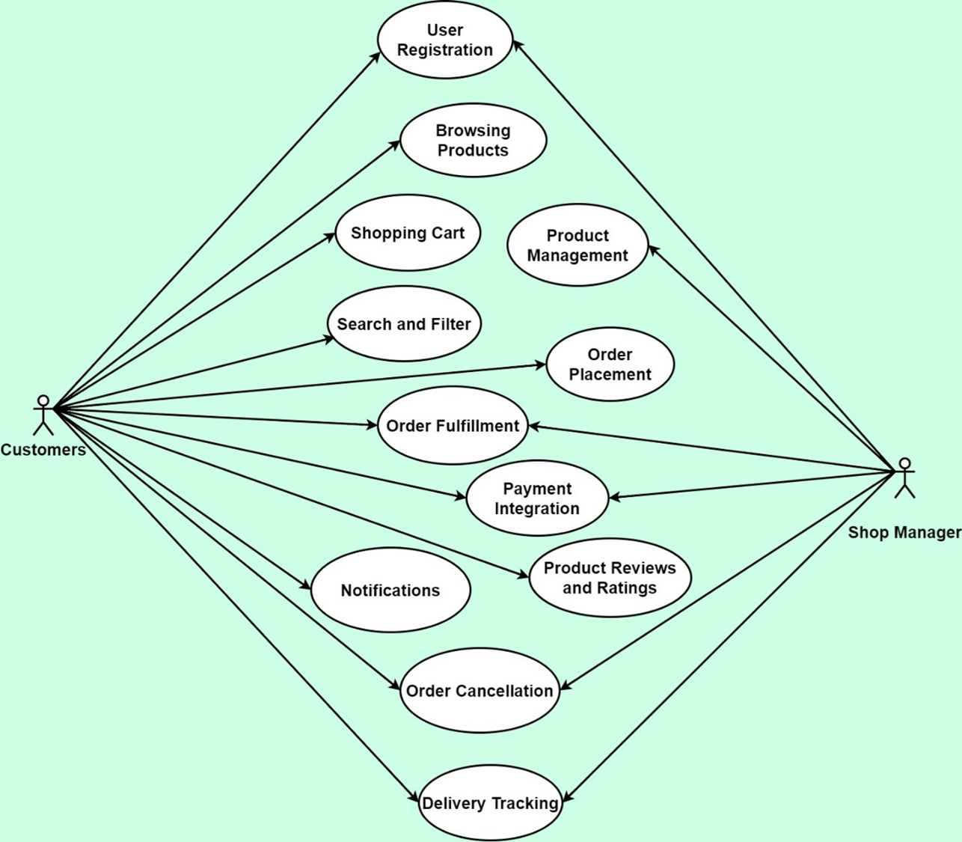

**Figure-4: User Case Diagram for Online Super Shop**

## User Case Description

### **Case Description-01: User Registration**

| **Use Case** | User Registration | |
| --- | --- | --- |
| **Goal**  <a longer statement of the goal in context if needed> | Allow users to register in the system. | |
| **Preconditions**  <what we expect is already the state of the world> | The user is not registered in the system. | |
| **Success End Condition**  <the state of the world upon successful completion> | The user successfully registers and gains access to the system. | |
| **Failed End Condition**  <the state of the world if goal abandoned> | Registration is unsuccessful. | |
| **Primary Actors:**  **Secondary Actors:** | Customers | |
| **Trigger**  <the action upon the system that starts use case> | The user initiates the registration process. | |
| **Description / Main Success Scenario**  <the steps of the scenario from trigger to goal delivery and any clean up after> | **Step** | **Action** |
| 1 | The user accesses the registration page. |
|  |  |
| 2 | The user provides required information, including name, email address, and password. |
| 3 | The system validates the entered information. |
| 4 | If validation is successful, the system creates a new user account. |
| 5 | The system sends a confirmation email to the user for account verification. |
| 6 | The user clicks the verification link in the email. |
| 7 | The system activates the user account. |
| **Alternative Flows**  <a: condition causing branching>  <a1: action or name of sub use case> | If the user provides invalid information, the system prompts for corrections. | |
| **Quality Requirements** | The registration process should be completed within two minutes. | |

## 

### **Case Description-02: Product Management**

| **Use Case** | Product Management | |
| --- | --- | --- |
| **Goal**  <a longer statement of the goal in context if needed> | Enable shop managers to manage product information. | |
| **Preconditions**  <what we expect is already the state of the world> | Shop Manager is logged into the system. | |
| **Success End Condition**  <the state of the world upon successful completion> | Product information is successfully updated in the system. | |
| **Failed End Condition**  <the state of the world if goal abandoned> | Product information is not updated. | |
| **Primary Actors:**  **Secondary Actors:** | Shop Manager | |
| **Trigger**  <the action upon the system that starts use case> | Shop Manager accesses the product management interface. | |
| **Description / Main Success Scenario**  <the steps of the scenario from trigger to goal delivery and any clean up after> | **Step** | **Action** |
| 1 | The Shop Manager accesses the product management interface.. |
| 2 | The system displays a list of existing products. |
| 3 | The Shop Manager can add new products, edit existing ones, or remove products. |
| 4 | The Shop Manager updates product details, such as name, description, and price. |
| 5 | The system validates and saves the changes. |
| **Alternative Flows**  <a: condition causing branching>  <a1: action or name of sub use case> | If the Shop Manager encounters an issue, the system provides error messages. | |
| **Quality Requirements** | Product information updates should be reflected in real-time. | |

## 

### **Case Description-03: Browsing Products**

| **Use Case** | Browsing Products | |
| --- | --- | --- |
| **Goal**  <a longer statement of the goal in context if needed> | Allow users to browse and view product information. | |
| **Preconditions**  <what we expect is already the state of the world> | User is on the home page or product catalog. | |
| **Success End Condition**  <the state of the world upon successful completion> | User has explored product information on the platform. | |
| **Failed End Condition**  <the state of the world if goal abandoned> | User is unable to access product information. | |
| **Primary Actors:**  **Secondary Actors:** | Customers | |
| **Trigger**  <the action upon the system that starts use case> | User navigates to the product catalog. | |
| **Description / Main Success Scenario**  <the steps of the scenario from trigger to goal delivery and any clean up after> | **Step** | **Action** |
| 1 | The user navigates through product categories or featured items. |
| 2 | The system displays a grid of products with basic information. |
| 3 | The user clicks on a product for detailed information. |
| 4 | The system displays detailed product information, including images, description, and price. |
| **Alternative Flows**  <a: condition causing branching>  <a1: action or name of sub use case> | The user can refine the product list based on search criteria. | |
| **Quality Requirements** | Product information should be loaded within three seconds. | |

## 

### **Case Description-04: Shopping Cart**

| **Use Case** | Shopping Cart | |
| --- | --- | --- |
| **Goal**  <a longer statement of the goal in context if needed> | Enable users to add products to a shopping cart and proceed to checkout. | |
| **Preconditions**  <what we expect is already the state of the world> | User is logged in and has selected products for purchase. | |
| **Success End Condition**  <the state of the world upon successful completion> | Products are in the user's shopping cart for order placement. | |
| **Failed End Condition**  <the state of the world if goal abandoned> | Products are not added to the shopping cart. | |
| **Primary Actors:**  **Secondary Actors:** | Customers | |
| **Trigger**  <the action upon the system that starts use case> | User proceeds to checkout from the shopping cart. | |
| **Description / Main Success Scenario**  <the steps of the scenario from trigger to goal delivery and any clean up after> | **Step** | **Action** |
| 1 | The user adds products to the shopping cart. |
| 2 | The system updates the shopping cart total. |
| 3 | The user can view and manage the items in the shopping cart. |
| 4 | The user proceeds to checkout. |
| **Alternative Flows**  <a: condition causing branching>  <a1: action or name of sub use case> | The user can refine the product list based on search criteria. | |
| **Quality Requirements** | Product information should be loaded within three seconds. | |

### **Case Description-05: Search and Filter**

| **Use Case** | Search and Filter | |
| --- | --- | --- |
| **Goal**  <a longer statement of the goal in context if needed> | Allow users to search for products and apply filters. | |
| **Preconditions**  <what we expect is already the state of the world> | User is on the product catalog or search page. | |
| **Success End Condition**  <the state of the world upon successful completion> | User has a narrowed-down set of products based on search criteria. | |
| **Failed End Condition**  <the state of the world if goal abandoned> | Search and filtering options are not effective. | |
| **Primary Actors:**  **Secondary Actors:** | Customers | |
| **Trigger**  <the action upon the system that starts use case> | User enters search terms or applies filters. | |
| **Description / Main Success Scenario**  <the steps of the scenario from trigger to goal delivery and any clean up after> | **Step** | **Action** |
| 1 | The user enters search terms or applies filters. |
| 2 | The system updates the product grid based on search criteria. |
| 3 | The user can further refine search results or reset filters. |
| **Alternative Flows**  <a: condition causing branching>  <a1: action or name of sub use case> | The system suggests autocomplete options based on entered search terms. | |
| **Quality Requirements** | Search results should be displayed within two seconds. | |

### 

### **Case Description-06: Order Placement**

| **Use Case** | Order Placement | |
| --- | --- | --- |
| **Goal**  <a longer statement of the goal in context if needed> | Enable users to place an order for selected products. | |
| **Preconditions**  <what we expect is already the state of the world> | User has selected products and is ready to make a purchase. | |
| **Success End Condition**  <the state of the world upon successful completion> | Order is successfully placed, and the user receives an order confirmation. | |
| **Failed End Condition**  <the state of the world if goal abandoned> | Order placement is unsuccessful. | |
| **Primary Actors:**  **Secondary Actors:** | Customers | |
| **Trigger**  <the action upon the system that starts use case> | User confirms the order details. | |
| **Description / Main Success Scenario**  <the steps of the scenario from trigger to goal delivery and any clean up after> | **Step** | **Action** |
| 1 | The user proceeds to checkout from the shopping cart. |
| 2 | The system displays the order summary, including selected items and total cost. |
| 3 | The user confirms the order details. |
| 4 | The system prompts the user to choose a delivery address and payment method. |
| 5 | The user provides necessary information for delivery and selects a payment method. |
| 6 | The system validates the information and processes the order. |
| **Alternative Flows**  <a: condition causing branching>  <a1: action or name of sub use case> | If the user encounters issues during payment, the system provides guidance. | |
| **Quality Requirements** | Order processing should take no longer than five seconds. | |

## 

### **Case Description-07: Payment Integration**

| **Use Case** | Payment Integration | |
| --- | --- | --- |
| **Goal**  <a longer statement of the goal in context if needed> | Integrate secure payment processing for user transactions. | |
| **Preconditions**  <what we expect is already the state of the world> | User is at the checkout stage, and payment information is required. | |
| **Success End Condition**  <the state of the world upon successful completion> | Payment is successfully processed, and the order is confirmed. | |
| **Failed End Condition**  <the state of the world if goal abandoned> | Payment processing is unsuccessful, and the order is not confirmed. | |
| **Primary Actors:**  **Secondary Actors:** | Customers | |
| **Trigger**  <the action upon the system that starts use case> | User selects a payment method during the checkout process. | |
| **Description / Main Success Scenario**  <the steps of the scenario from trigger to goal delivery and any clean up after> | **Step** | **Action** |
| 1 | The user selects a payment method during the checkout process. |
| 2 | The system redirects the user to the chosen payment gateway. |
| 3 | The user enters payment details and confirms the transaction. |
| 4 | The payment gateway processes the transaction and sends a confirmation to the system. |
| 5 | The system updates the order status to "Paid." |
| **Alternative Flows**  <a: condition causing branching>  <a1: action or name of sub use case> | If payment authorization fails, the system prompts the user to retry or choose an alternative method. | |
| **Quality Requirements** | Payment processing should take no longer than ten seconds. | |

## 

### **Case Description-08: Product Reviews and Ratings**

| **Use Case** | Product Reviews and Ratings | |
| --- | --- | --- |
| **Goal**  <a longer statement of the goal in context if needed> | Allow registered customers to submit reviews and ratings for products. | |
| **Preconditions**  <what we expect is already the state of the world> | User has purchased a product. | |
| **Success End Condition**  <the state of the world upon successful completion> | Product has updated reviews and ratings. | |
| **Failed End Condition**  <the state of the world if goal abandoned> | Product reviews and ratings are not updated. | |
| **Primary Actors:**  **Secondary Actors:** | Registered Customer | |
| **Trigger**  <the action upon the system that starts use case> | User accesses the product details page. | |
| **Description / Main Success Scenario**  <the steps of the scenario from trigger to goal delivery and any clean up after> | **Step** | **Action** |
| 1 | The user accesses the product details page. |
| 2 | The system displays options to leave a review and provide a rating. |
| 3 | The user submits a review and assigns a rating to the product. |
| 4 | The system updates the product's overall rating and displays the review. |
| **Alternative Flows**  <a: condition causing branching>  <a1: action or name of sub use case> | If the user decides not to submit a review, the system retains the previous ratings. | |
| **Quality Requirements** | Reviews and ratings should be processed and updated in real-time. | |

### **Case Description-09: Notifications**

| **Use Case** | Notifications | |
| --- | --- | --- |
| **Goal**  <a longer statement of the goal in context if needed> | Keep users informed about important events and updates. | |
| **Preconditions**  <what we expect is already the state of the world> | Relevant events or actions trigger notifications. | |
| **Success End Condition**  <the state of the world upon successful completion> | Users receive timely notifications about important events. | |
| **Failed End Condition**  <the state of the world if goal abandoned> | Users do not receive notifications. | |
| **Primary Actors:**  **Secondary Actors:** | Customers | |
| **Trigger**  <the action upon the system that starts use case> | System generates notifications for order updates, promotions, or other relevant information. | |
| **Description / Main Success Scenario**  <the steps of the scenario from trigger to goal delivery and any clean up after> | **Step** | **Action** |
| 1 | The system generates notifications for order updates, promotions, or other relevant information. |
| 2 | Notifications are sent to the respective users via email, in-app messages, or push notifications. |
| 3 | Users can view and manage notifications in their account settings. |
| **Alternative Flows**  <a: condition causing branching>  <a1: action or name of sub use case> | Users can customize their notification preferences in the system settings. | |
| **Quality Requirements** | Notifications should be delivered within one minute of the triggering event. | |

### **Case Description-10: Order Cancellation**

| **Use Case** | Order Cancellation | | |
| --- | --- | --- | --- |
| **Goal**  <a longer statement of the goal in context if needed> | Enable customers or Shop Manager to cancel orders within a specified timeframe and ensure inventory and financial adjustments are handled efficiently. | | |
| **Preconditions**  <what we expect is already the state of the world> | Customer is logged into their account, and the order is within the cancellable timeframe. | | |
| **Success End Condition**  <the state of the world upon successful completion> | The order is successfully canceled, inventory is updated, and a refund is initiated if applicable. | | |
| **Failed End Condition**  <the state of the world if goal abandoned> | The order remains active, inventory and financial records are unchanged. | | |
| **Primary Actors:**  **Secondary Actors:** | Customers  Shop Manager | | |
| **Trigger**  <the action upon the system that starts use case> | Customer initiates the cancellation process for an order. | | |
| **Description / Main Success Scenario**  <the steps of the scenario from trigger to goal delivery and any clean up after> | **Step** | | **Action** |
| 1 | | Customer accesses their order history. |
| 2 | | System displays list of recent orders with options. |
| 3 | | Customer selects cancellation for an eligible order. |
| 4 | | System asks for confirmation. |
| 5 | | Customer confirms. |
| 6 | | System checks eligibility and updates status. |
| 7 | | Inventory adjusted; refund initiated. |
| 8 | | Customer receives confirmation. |
| **Alternative Flows**  <a: condition causing branching>  <a1: action or name of sub use case> | a | Order not in cancellable timeframe - system informs customer. | |
| b | Product type not cancellable - customer notified. | |
| c | Technical issue with adjustments - Shop Manager notified. | |
| **Quality Requirements** | Simple and intuitive cancellation process  Real-time processing of inventory updates and refunds  Clear feedback to customer during process  Security measures to prevent fraud | | |

### **Case Description-11: Delivery Tracking**

| **Use Case** | Delivery Tracking | |
| --- | --- | --- |
| **Goal**  <a longer statement of the goal in context if needed> | Allow users to track the real-time status of their deliveries. | |
| **Preconditions**  <what we expect is already the state of the world> | Order is in the "Out for Delivery" status. | |
| **Success End Condition**  <the state of the world upon successful completion> | Users can track the real-time status of their deliveries. | |
| **Failed End Condition**  <the state of the world if goal abandoned> | Users cannot track the delivery status. | |
| **Primary Actors:**  **Secondary Actors:** | Customers  Shop Manager | |
| **Trigger**  <the action upon the system that starts use case> | Order is in the "Out for Delivery" status. | |
| **Description / Main Success Scenario**  <the steps of the scenario from trigger to goal delivery and any clean up after> | **Step** | **Action** |
| 1 | The system provides a real-time tracking interface for the registered customer. |
| 2 | The Delivery Man updates the delivery status upon successful completion. |
| **Alternative Flows**  <a: condition causing branching>  <a1: action or name of sub use case> | If the delivery is delayed, the system provides updated estimated delivery times. | |
| **Quality Requirements** | Delivery status updates should be real-time. | |

# **Project Block Diagram**

## Block Diagram-1: Customer

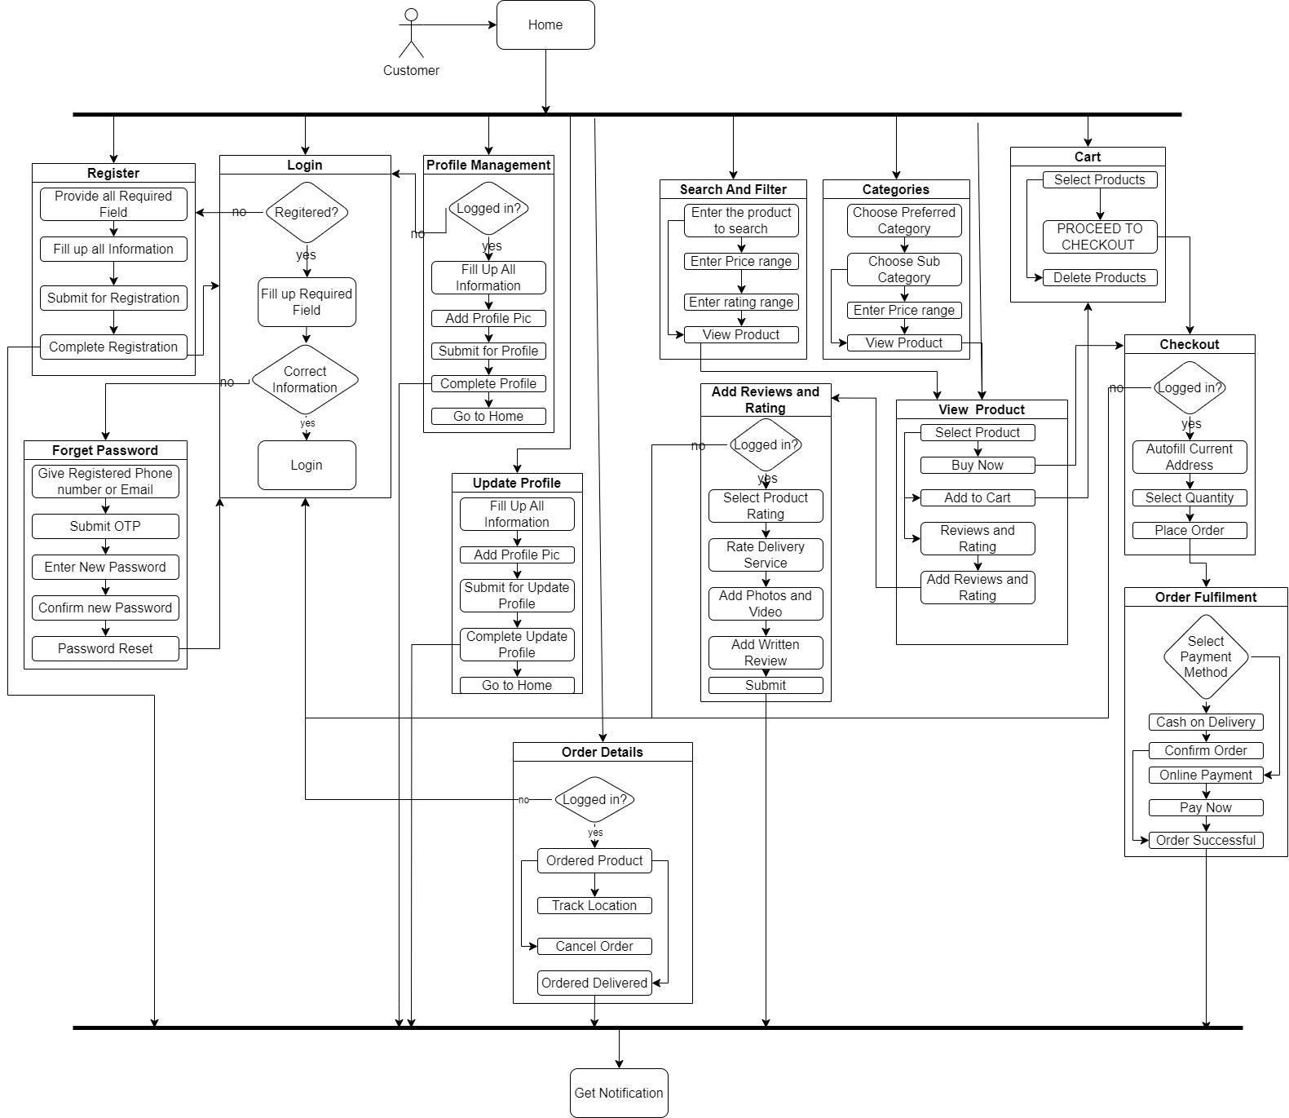

## Block Diagram-2: Manager

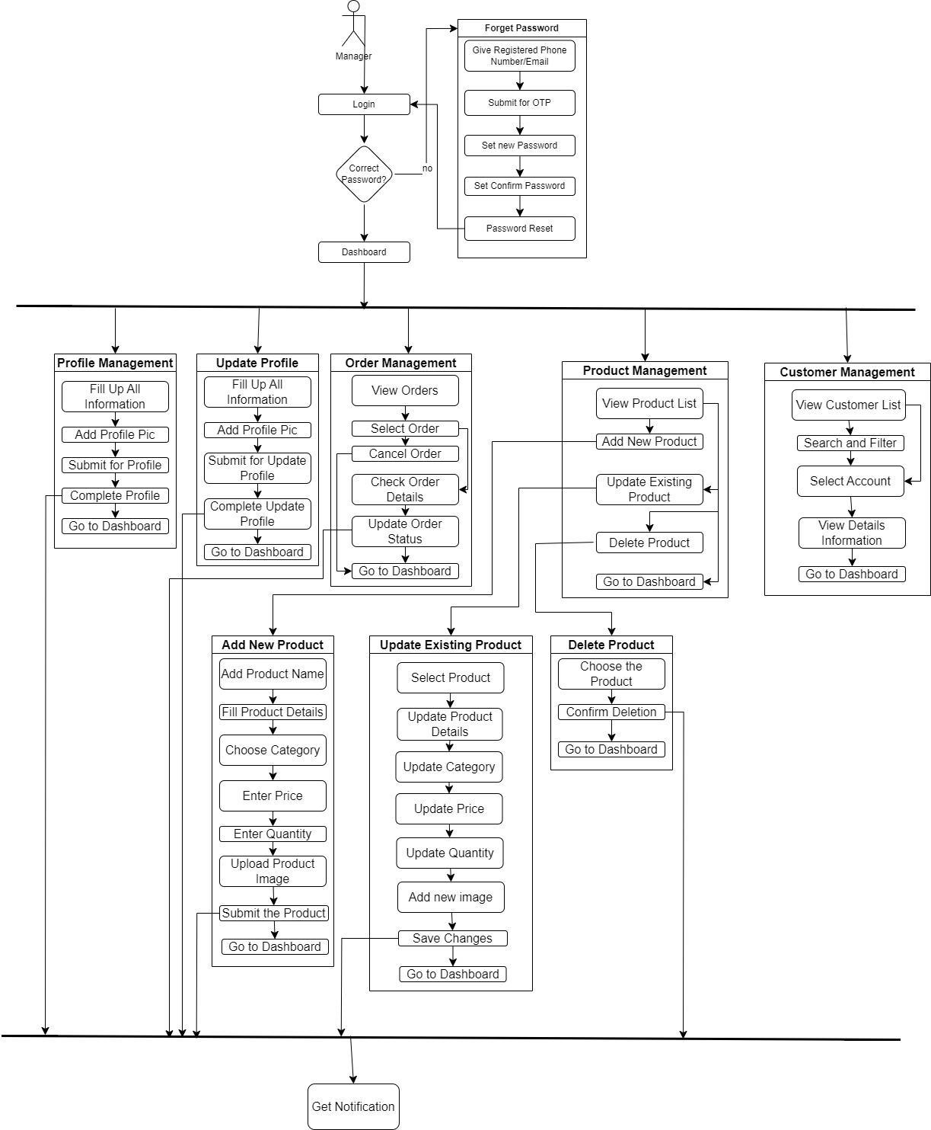

## 

# **Activity Diagram**

## Activity Diagram-1: User Registration and Login

## Activity Diagram-2: Browsing and View Product

## Activity Diagram-3: Shopping Cart

## Activity Diagram-4: Product Management

## Activity Diagram-5: Search

## Activity Diagram-6: Order

## Activity Diagram-7: Payment

## Activity Diagram-8: Product Reviews and Ratings

## Activity Diagram-9: Order Cancellation

## Activity Diagram-10: Delivery Tracking

# **Sequence Diagram**

## Sequence Diagram-1: User Registration and Login

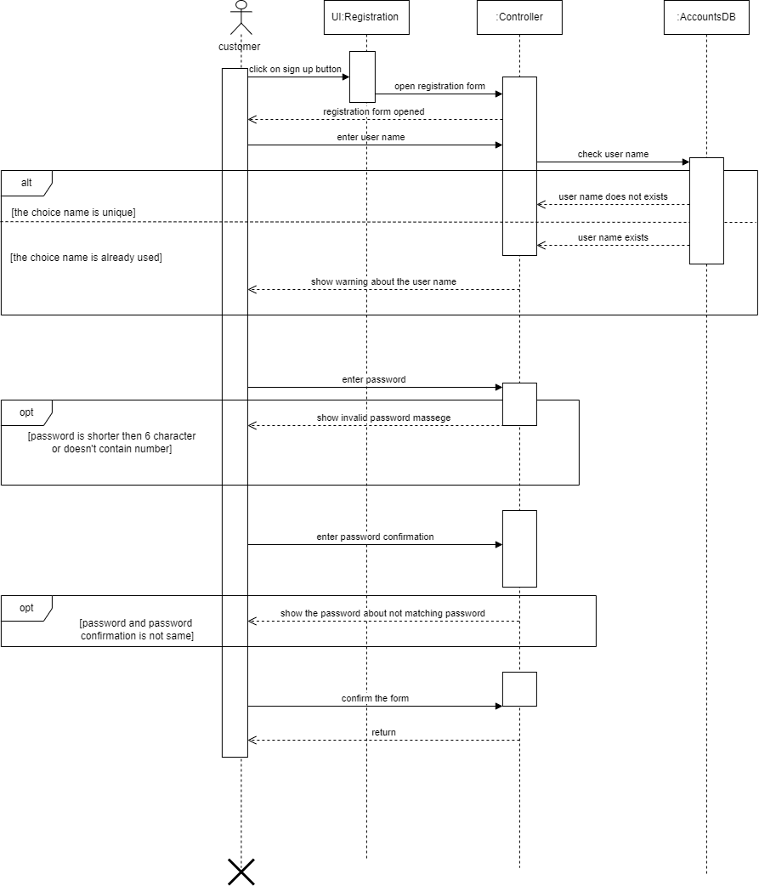

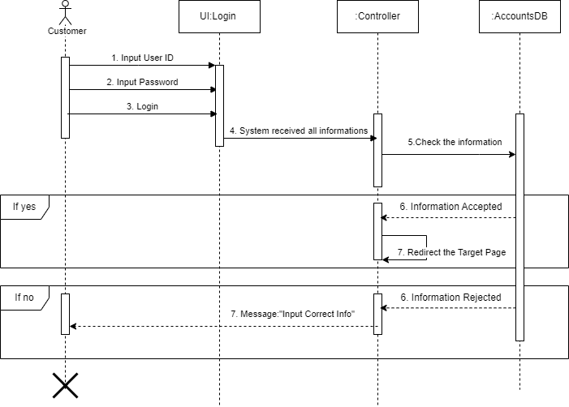

## Sequence Diagram-2: View Product

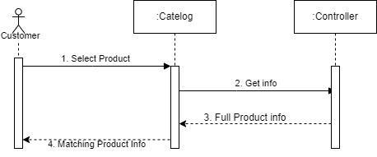

## Sequence Diagram-3: Shopping Cart

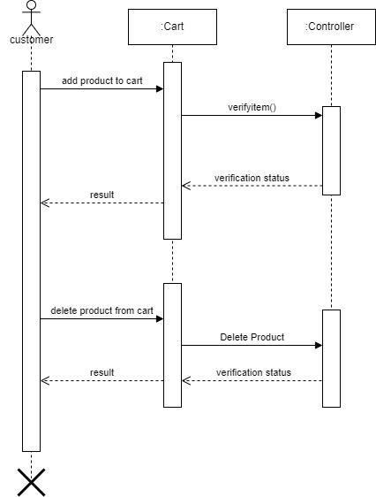

## Sequence Diagram-4: Product Management

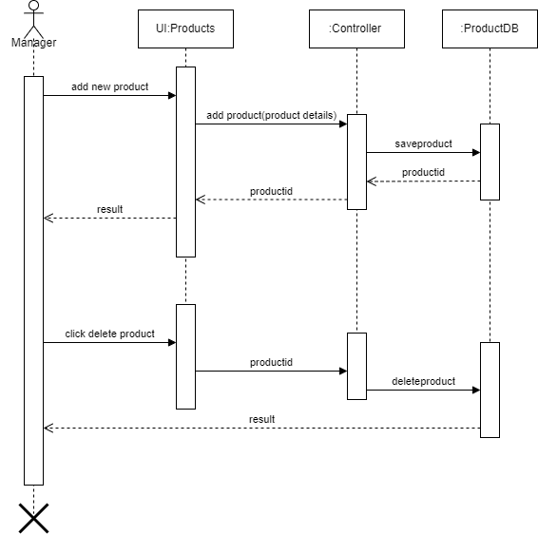

## Sequence Diagram-5: Search Product

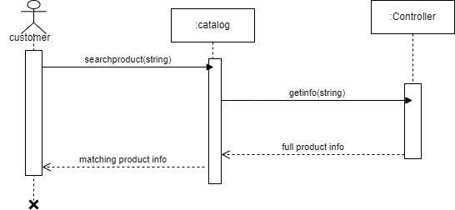

## Sequence Diagram-6: Order

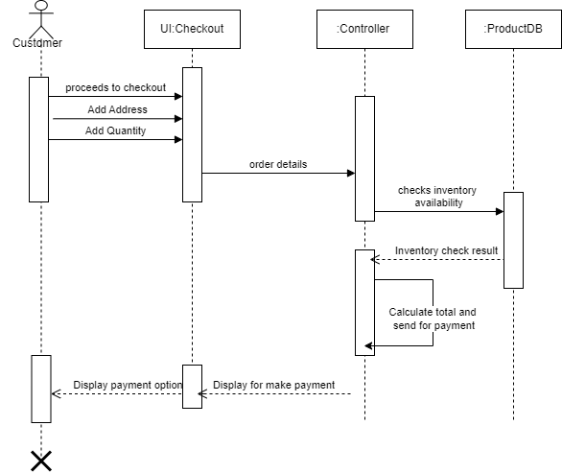

## Sequence Diagram-7: Payment

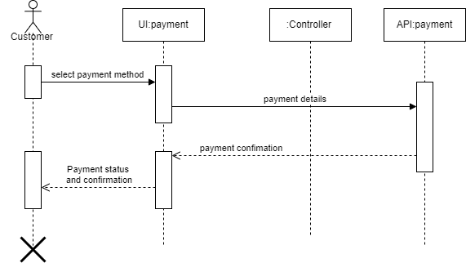

## Sequence Diagram-8: Product Reviews and Ratings

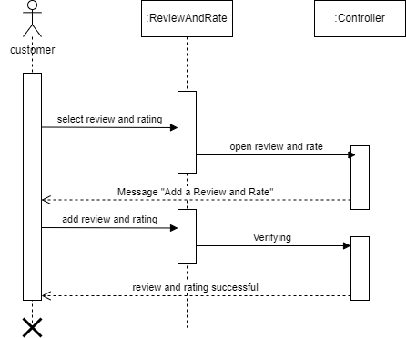

## Sequence Diagram-9: Order Cancellation

## Sequence Diagram-10: Delivery Tracking

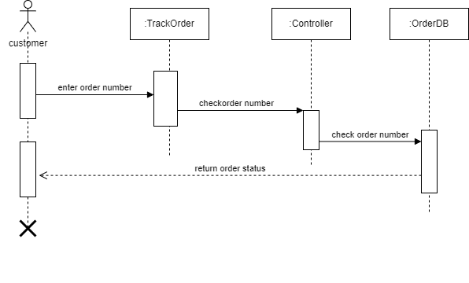

# **Online Super Shop Project Class Diagram**

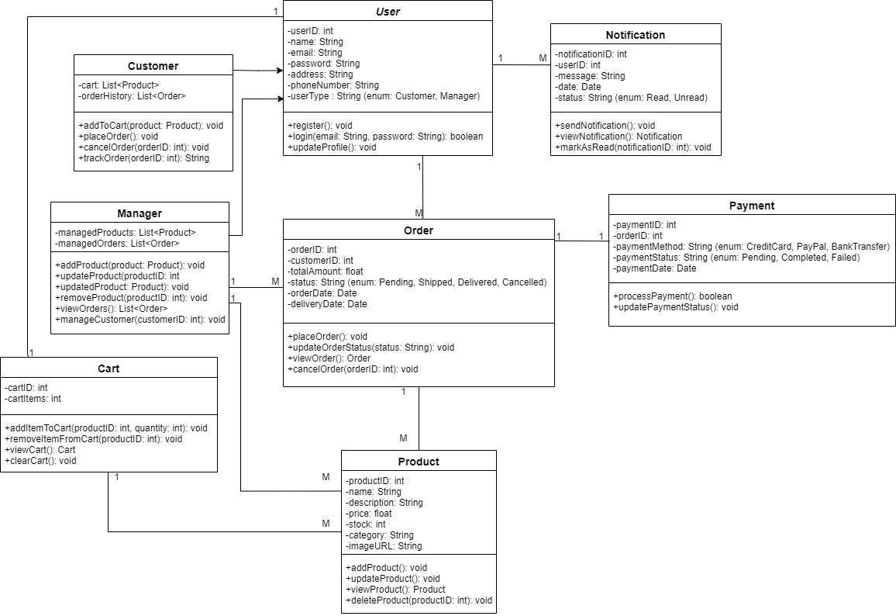

# 

# 

# 

# 

# **Online Super Shop Project ER Diagram**

